# Proposal

for Website Development

of Funflix.

**Date:** September 6, 2019

**Name:** Lakshminarayana Madabhushi

**Company:**  MLN IT Solutions

Table of Contents

Proposal 0

MLN IT Solutions 3

Website Development Project 3

**Background:** 3

**Services Provided by us** 3

**Why Choose Us** 4

**Qualifications:** 4

**Goals of the site:** 5

**How data is collected and how it is used?** 6

**Target audience discussion:** 6

**Story board**: 7

**Landing Page:** 7

**Login Page:** 8

**Signup Page:** 10

**My Profile page:** 11

**Home Page:** 12

**TV Shows Page:** 13

**Movies Page:** 14

**Home page (Admin):** 15

**Edit Primary Table:** 16

**Budget:** 16

**Workplan:** 17

**Workback:** 18

**Wireframes:** 20

**Sitemap:** 21

Admin 21

Funflix Site Map: 21

**Data Model:** 22

Conceptual Data Model: 22

ER Diagram 23

**Invoice:** 24

**Conclusion:** 24

Proposal

# MLN IT Solutions

# Website Development Project

From: Narayana Madabhushi<madabhushi-l@webmail.uwinnipeg.ca>

To: Steve George <edu@pagerange.com>

Date: September 6, 2019

## **Background:**

MLN IT Solutions is one of the leading IT companies in Winnipeg providing live streaming services and web development services. We have over 10 years of experience in providing extremely effective solutions to clients. We come up with innovative, fast & reliable web broadcasting & live streaming services/solutions and have a client base of 28.

Quality, innovative and cost-effective services are our forte. We provide specialized services to handle all regular aspects of building a website, from initial design and logo development to content management applications for sites of all sizes ranging from single pages, blogs and small business sites to full-scale corporate websites. We are extremely thrilled by your business idea of serving as a media-services provider online. We would like to help you in easy dispersal of your message to the masses across the globe using cutting-edge technologies.

### **Services Provided by us**

#### **Web Designing**

* + We are providing quality web site design, specifically tailored for small and medium-sized businesses.

#### **Audio/Video Hosting**

* + Our global Content Delivery Network (CDN) host and deliver your media content across the globe.

#### **Custom Web Portals**

* + We will eliminate your reliance on internal IT and web development teams by fully managing your portal!

### **Why Choose Us**

* We deliver cost-effective, innovative web solutions founded on our technical competency.
* All services delivered through highly trained and motivated teams.
* Anytime (24×7) online support and assistance.
* We offer the latest web technologies to provide customized solutions.

## **Qualifications:**

We are one of the leading companies in Winnipeg to provide the latest software solutions to businesses. We have a combination of highly experienced IT professionals, sales & marketing professionals, and photographers providing a variety of services to our customers, with more than 1000 people working in Winnipeg. Our motive is to improve our customer's businesses with creative and innovative solutions. We have 10 years of experience working with more than 50 clients including non-profitable organizations in Winnipeg and outside of Winnipeg.

Prospective Team that would be working on the proposed project:

1. Narayana Madabhushi - Project Manager (10 Years’ Experience), CEO
2. Ravikumar - Team Lead (10 Years’ Experience) & Co
3. Robert - Programmer (6 Years’ Experience)
4. Pandya - Programmer (6 Years’ Experience)
5. Sonu - Front end Developer (6 Years’ Experience)
6. Moiz - Tester (5 Years’ Experience)
7. Jack - Designer (6 Years’ Experience)
8. Michael - Content editor (6 Years’ Experience)
9. Surya - Cloud Specialist (6 Years’ Experience)

## **Goals of the site:**

From the request for proposal, I understand your idea needs to be implemented from scratch.

Keeping that in mind I have come up with the following objectives for developing the website:

* Develop a website with dynamic content using HTML, Php, MySQL.
* Use MySQL to maintain databases to store all the required data.
* The combination of PHP and MySQL to provide cost effective solutions that require low end hardware and less hassle.
* Enable the administrator to add more videos
* Enable the administrator to insert, delete and update records in primary table through forms.
* Clear navigation between pages and streamlined organized content.
* The ability for users to watch different tv shows and movies from a catalogue delivered to customers based on genre.
* The ability for users to login and logout
* Enable users to search content based on the title.
* Users can add videos to a list and maintain a personalized list.
* Escaping the output whenever you want to output something to the browser that came from the user input to prevent Cross Site Scripting
* Including a random token, a unique string with each request that is generated for each session to prevent CSRF attacks.
* Passwords are hashed and stored in the database to prevent dictionary attacks.

### **How data is collected and how it is used?**

Data is primarily stored in the following tables

* TV SHOWS - Consists of the list of tv shows to be displayed to the user.
* MOVIES – Consists of the list of movies to be displayed to the user.
* USERS – Consists of the data input by a Funflix user upon registration.
* PERSONALISED LIST AS VIEW LIST – Consists of the list of personalized lists of each user.
* GENRES – consists of the list of genres of the videos available

Pivot tables are used where many to many relationships exists to normalize the tables in the database.

## **Target audience discussion:**

* The global online television industry is developing quickly. People all over the world are increasingly choosing the Internet to view content instead of watching traditional television, forcing entertainment and media organizations to reinvent their business models and tap new revenue streams.
* The **primary audience** of the website would be movie buffs who are too busy to go out and watch movies.
* The **secondary audience** of the website would be people who want to get the most value for their money. The secondary audience could possibly be students who live on a budget. Providing a student plan for students would attract a lot of customers.
* The website’s **target audience** includes people between the ages of 17-60 and households with income levels of $30,000 and up, as you are planning to introduce it as a subscription-based service.
* The **tertiary audience** would include people above the age of 60, who might have limited technological experience and people who might live in locations with limited connectivity.

To address this concern, we will be developing lesser sized webpages, so that the website is still functional in such cases. It is also important to design the website in such a way that it is easy to navigate and that the content is streamlined.

## **Story board**:

### **Landing Page:**

Index page for the website which would contain links to login and sign up.

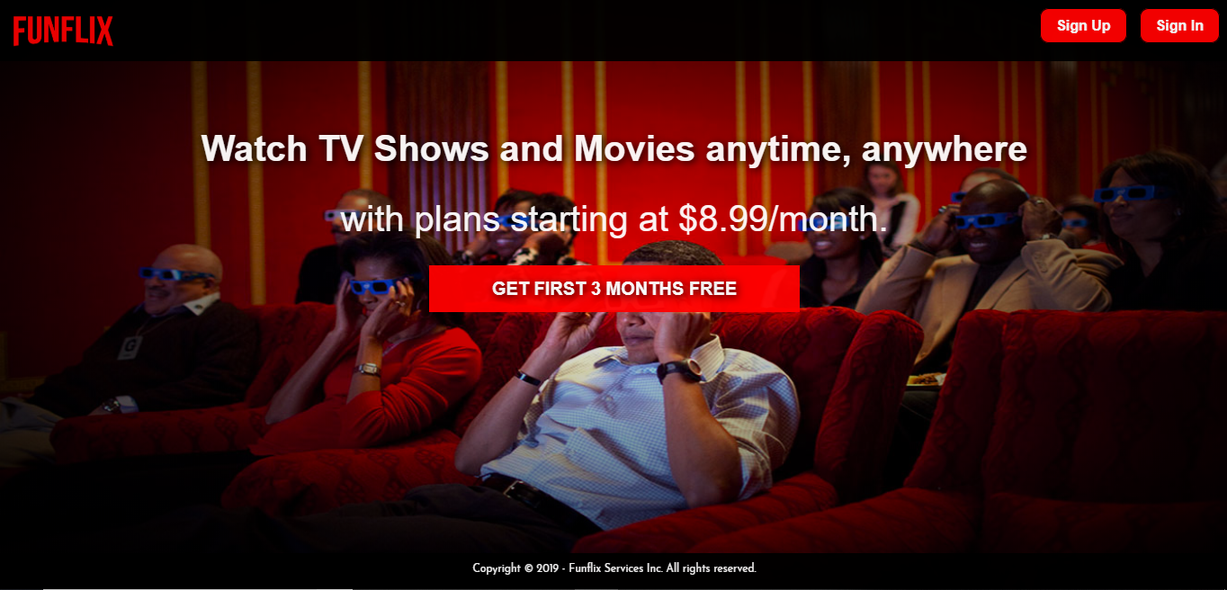

**Login Page:**

Will consist of 2 input fields to key in the username and password. On providing the admin credentials you would be redirected to the admin home page. On providing a normal user’s credentials you would be directed to the user’s profile page. 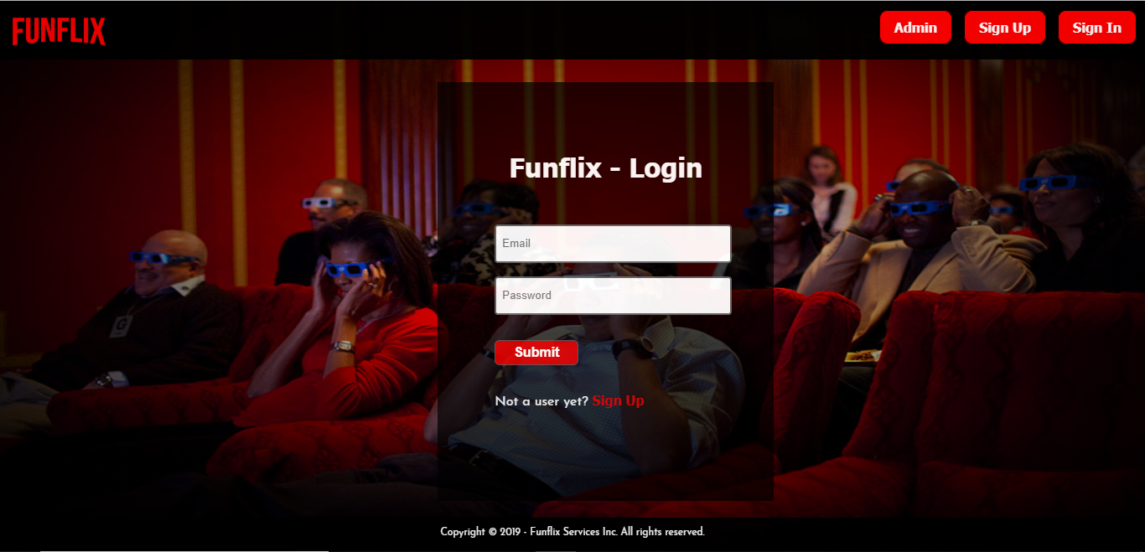

### 

### **Signup Page:**

Will consist of a form to get user information and register to the website. Password is hashed and saved in the website.

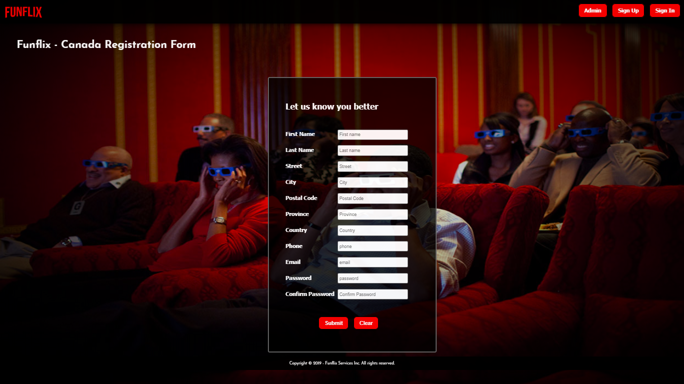­­­­

### **My Profile page:**

A successful login would redirect a registered user to their profile page. The profile page would display the user details.

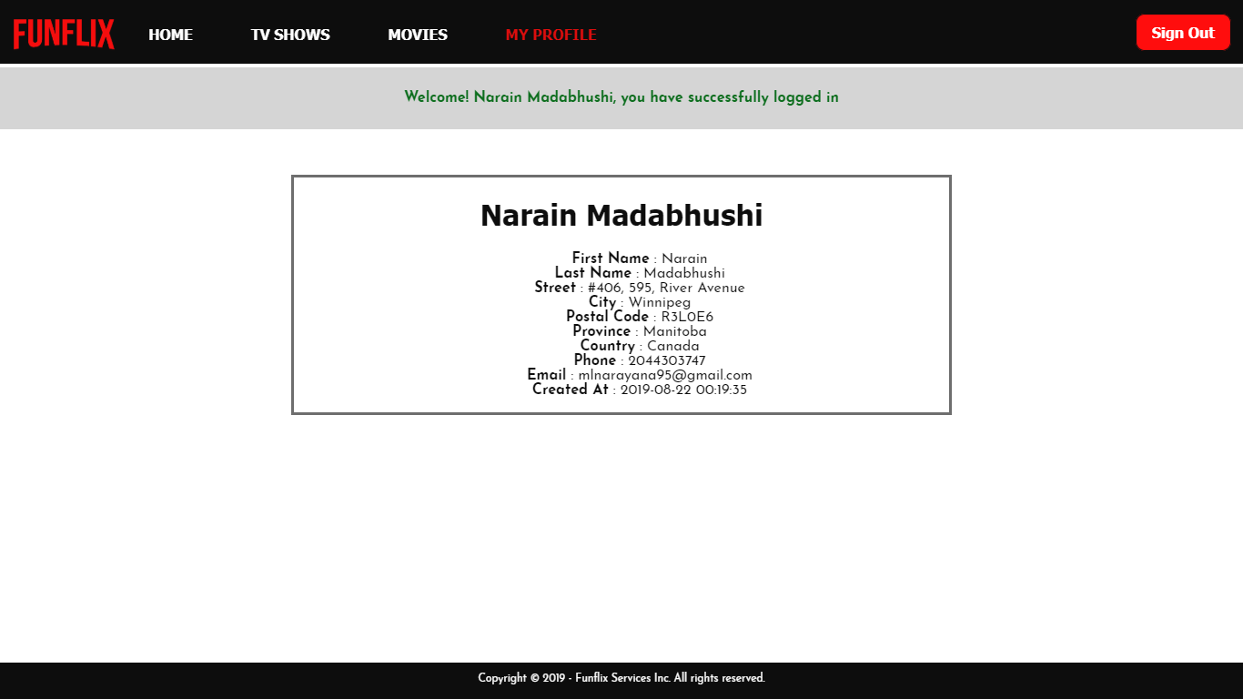

### **Home Page:**

A registered user will be able to access the home page after logging in to the website from the login page. Will consist of a header with home, tv shows, movies, and my profile.

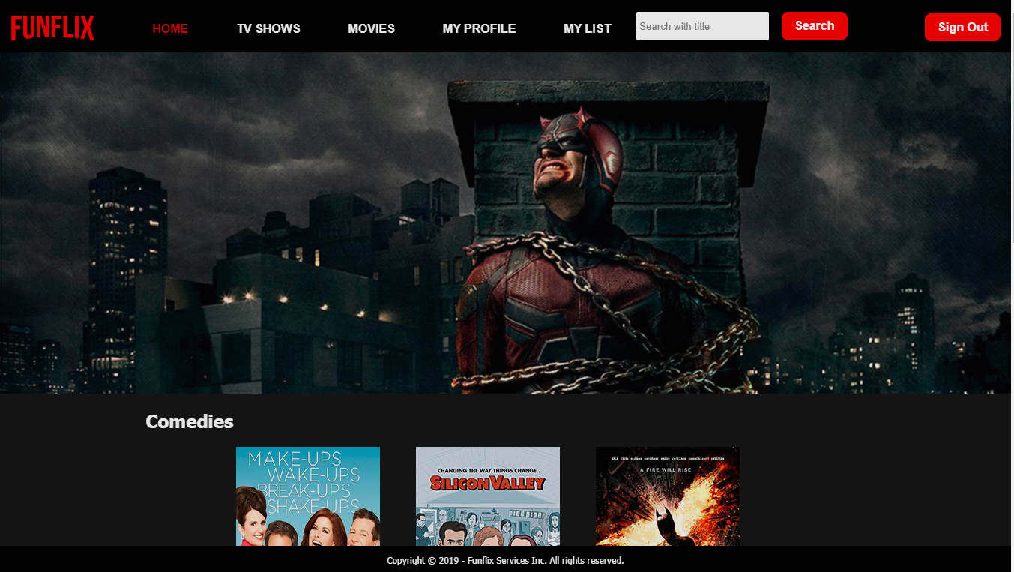

### **TV Shows Page:**

Can access this page from the home page by clicking on tv shows from the main menu.

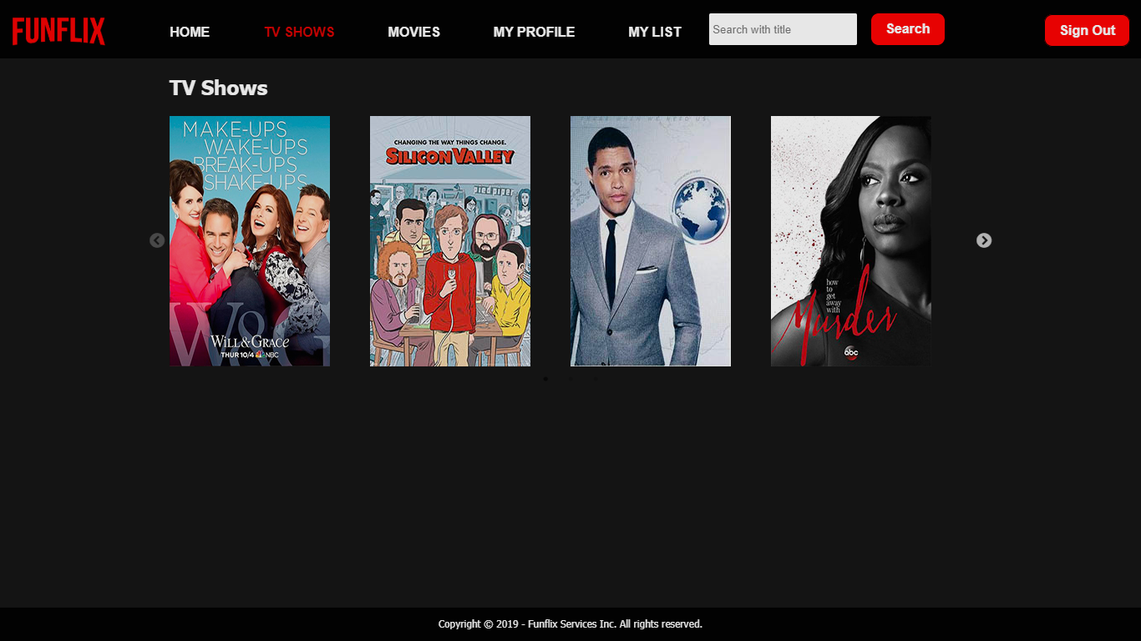

### 

### **Movies Page:**

Can access this page from the home page by clicking on movies from the main menu.

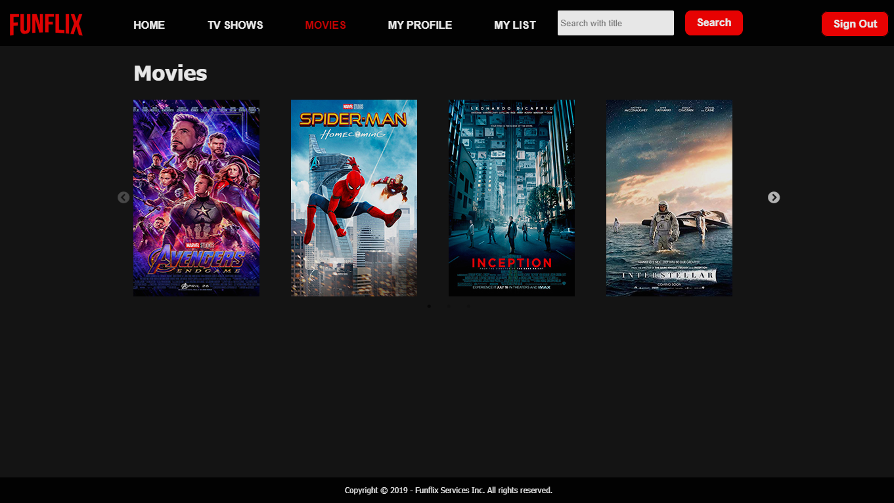

### **My List Page:**

User can create and add a video to a list from the detailed view page. Lists with videos added are displayed in my list page.

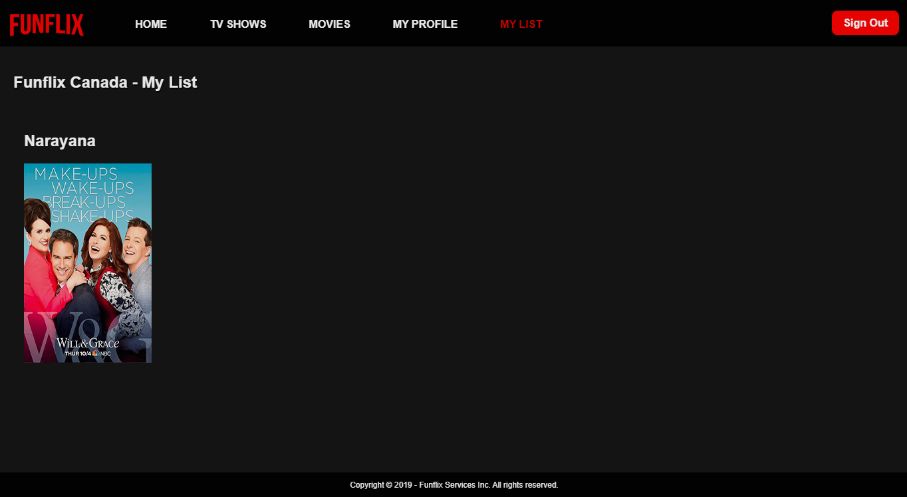

### **Detailed View page**

It has a detailed description of every movie or tv show available 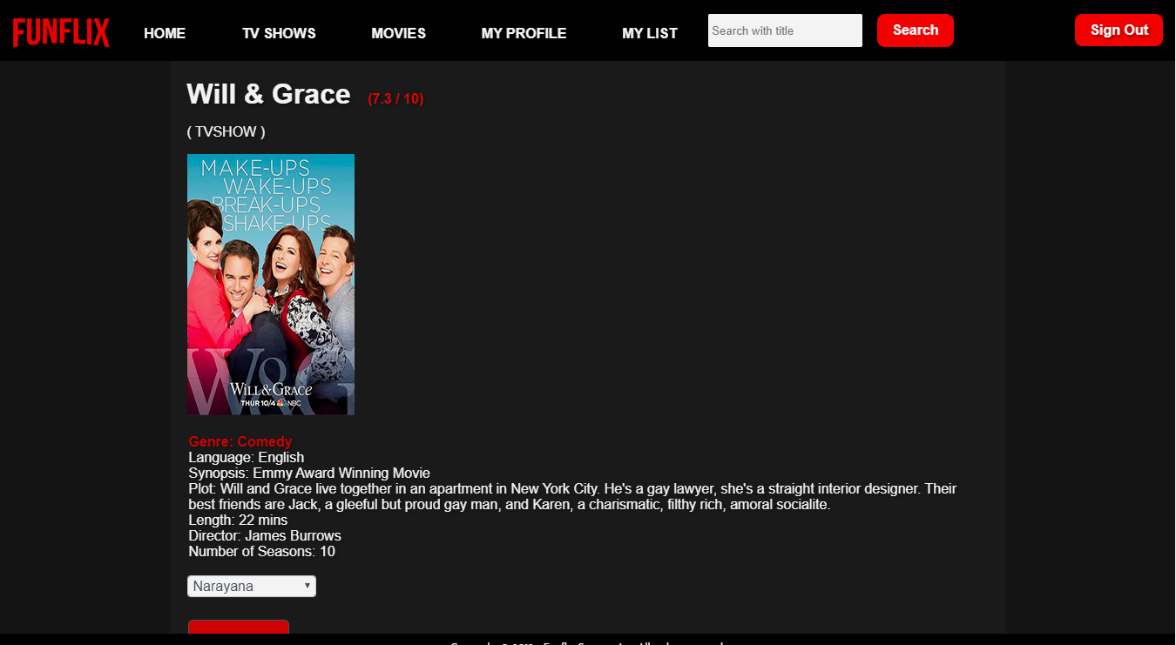

### **Home page (Admin):**

This page displays records from the primary table.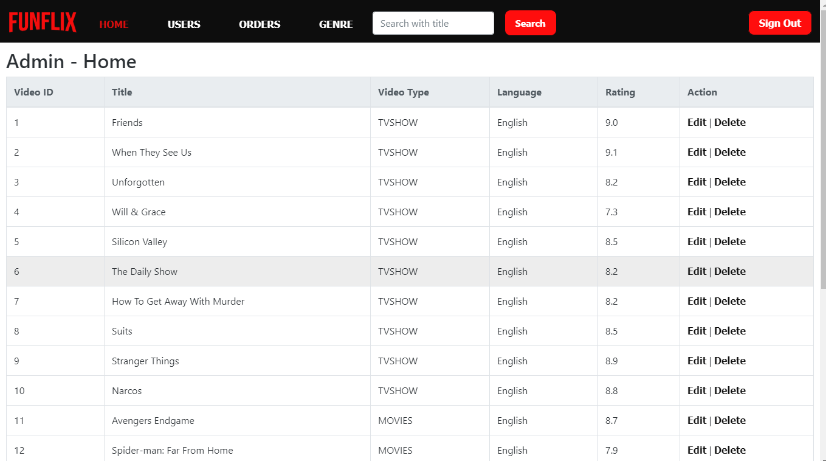

### **Edit Primary Table:**

This page allows the site administrator update records.

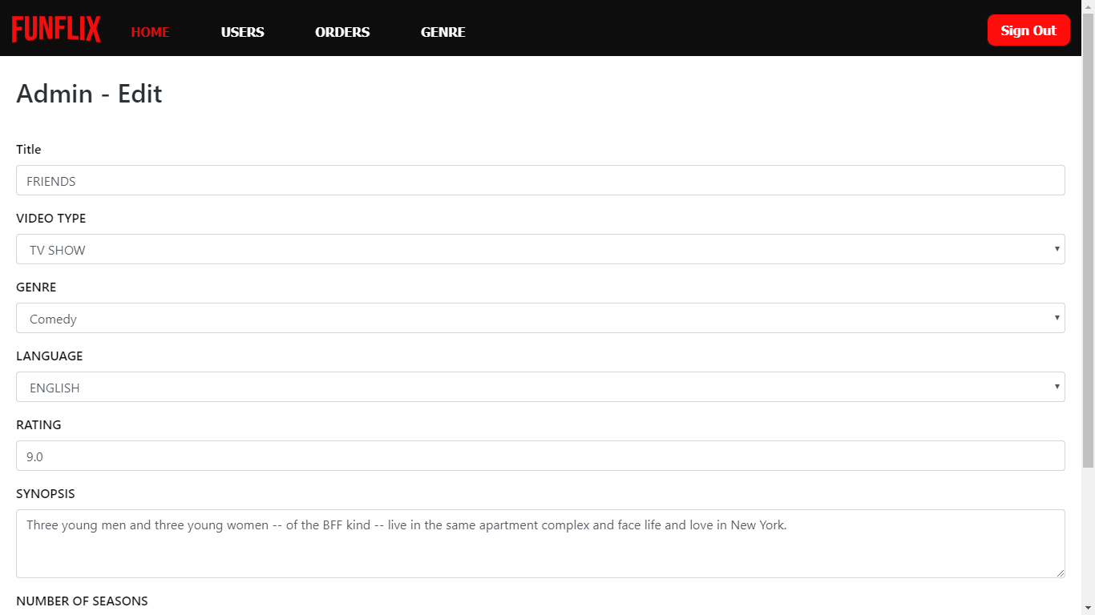

### **Admin Dashboard:**

This page displays aggregate stats for the admin to track and also the log data.

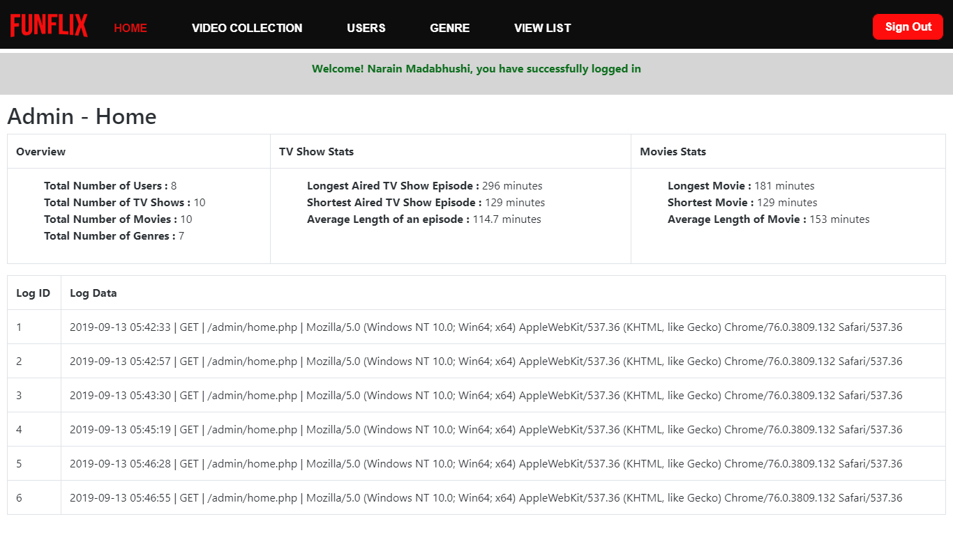

### **Admin – Users:**

This page displays all the users details from the table to the admin.

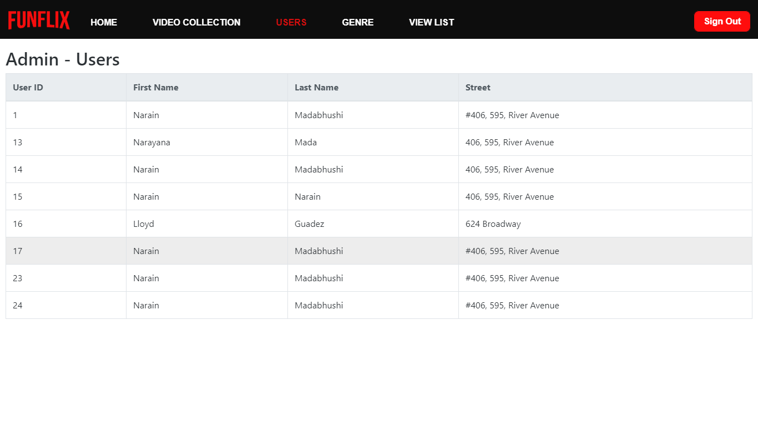

### **Admin – Genre**

This table displays all the different genres of videos available from the list.

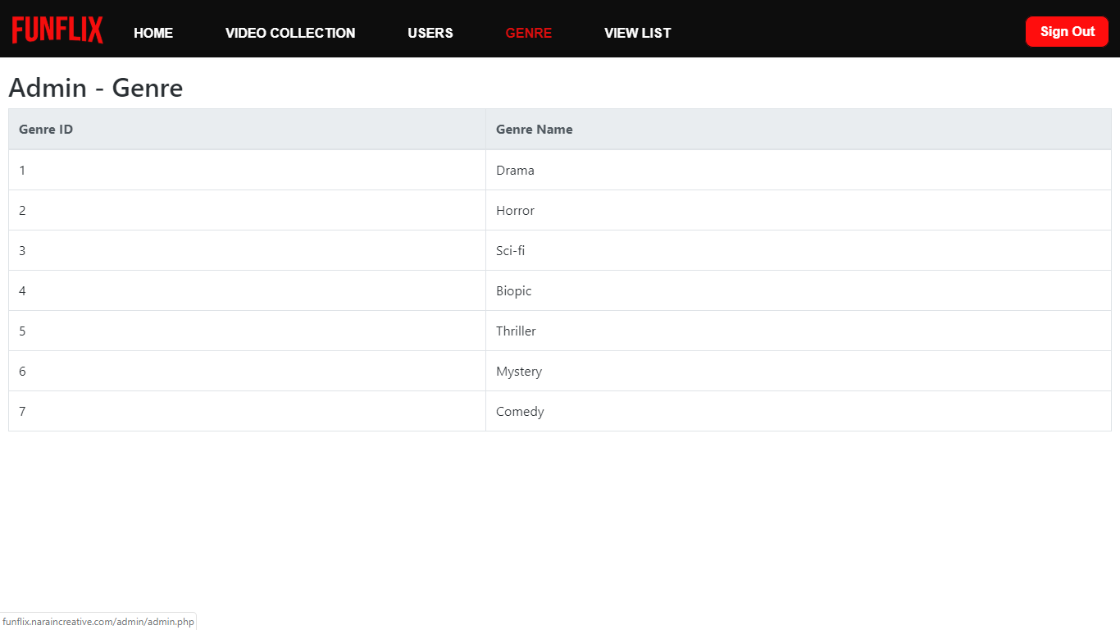

### **Admin – View List**

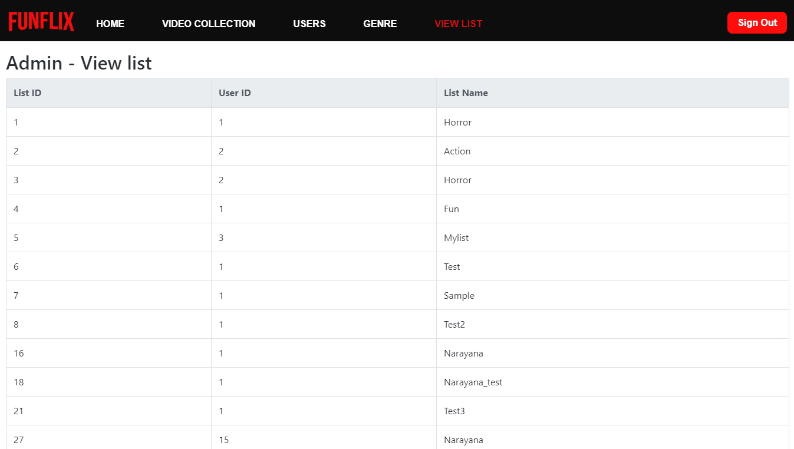

## **Budget:**

Below is the breakdown of the budget:

|  |  |  |
| --- | --- | --- |
| **PHASE** | **HOURS** | **CHARGE** |
| Planning | 15 | 750 CAD |
| Designing | 15 | 750 CAD |
| Coding & Programming | 40 | 2800 CAD |
| Launch | 2 | 60 CAD |
| Total | 4,360 CAD | |
| Total including Taxes | 4360 + 15% of Total = 5014 CAD | |

## **Workplan:**

We have come up with this successful approach to software development under which requirements and solutions evolve through the collaborative effort of self-organizing and cross-functional teams.

Following are the different phases:

1. **Planning/ Exploration:** In this phase, we would be meeting the Funflix stakeholders to get a better understanding of their requirements, so that all of us are on the same page. We would work on creating the content outline, sitemap, wireframes, and creative brief.

Deliverables: At the end of the planning phase we would have a content outline, sitemap, wireframes, creative brief, and technology brief.

1. **Design/ Content:** In this phase, we would be designing and editing existing content, creating a design layout for the entire website and would send it to the client for approval.

Deliverables: At the end of the design phase we would have an approved design and content for the coders and programmers to work on.

1. **Coding/ Programming:** In this phase, we would be working on building the website using PHP and MySQL. Will be performing unit testing and functional testing.

Deliverables: A fully functioning website which is bug-free and ready to live.

1. **Launch/ Maintenance**: In this phase, we would be working on setting up configurations on the server and preparing to go live.

Deliverables: A fully functioning website running on a web server.

## **Workback:**

From**:** Narayana Madabhushi, MLN

To**:** Steve George

Date**:** September 6, 2019

Re**:** Website Redevelopment Workback Schedule

|  |  |  |
| --- | --- | --- |
| Completion Date | Description of Work | Responsible |
| PLANNING AND EXPLORATION | | |
| September 6, 2019 | Contract Awarded | Page Range |
| September 6, 2019 | Kick off Meeting | MLN & Page Range |
| September 7, 2019 | Sitemap, Content Outline and Block Comps sent to client | MLN IT |
| September 8, 2019 | Sitemap, Content Outline and Block Comps approved | MLN IT |
| DESIGN/CONTENT | | |
| September 10, 2019 | Develop initial graphic design | MLN IT |
| September 11, 2019 | Create organized PSDs | MLN IT |
| September 11, 2019 | Review and update Content Outline | MLN IT |
| September 11, 2019 | Send design and Content for approval and approved by client. | MLN IT & Page Range |
| CODING/PROGRAMMING | | |
| September 13, 2019 | Coding in HTML and validate HTML &  Coding in CSS and validate CSS | MLN |
| September 13, 2019 | Define Data Model and normalize Data | MLN |
| September 14, 2019 | Developing the application logic using PHP and MySQL | MLN |
| September 14, 2019 | Get client’s approval on working website | MLN |
| LAUNCH/ MAINTENANCE | | |
| September 14, 2019 | Configuring Prod Environment | MLN |
| September 14, 2019 | Approval of Website in Prod Environment | MLN |
| September 14, 2019 | Hard Launch on Website with supporting campaigns and event | Page Range |

## **Wireframes:**

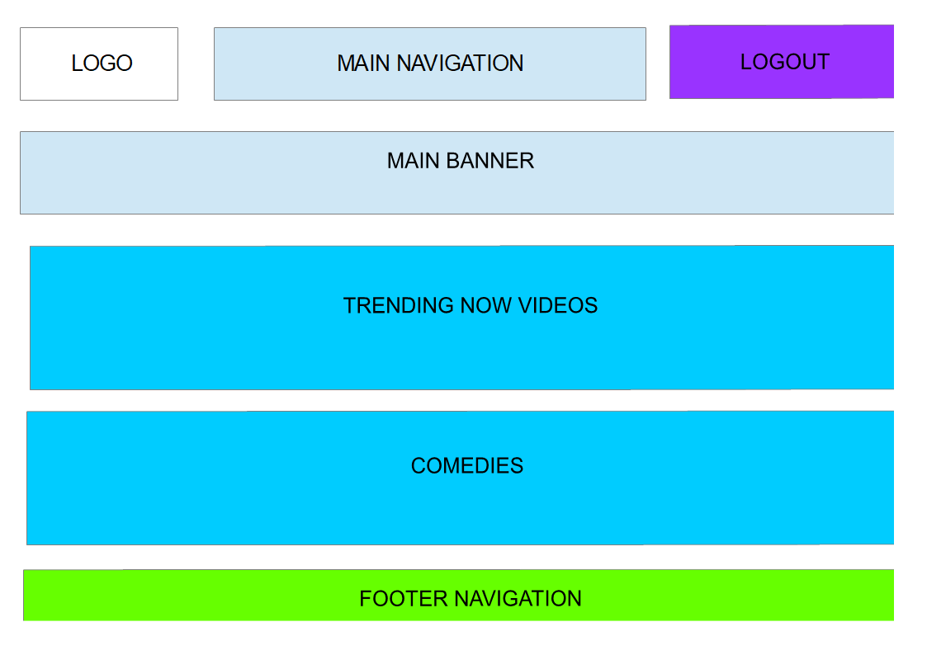

## **Sitemap:**

### Admin

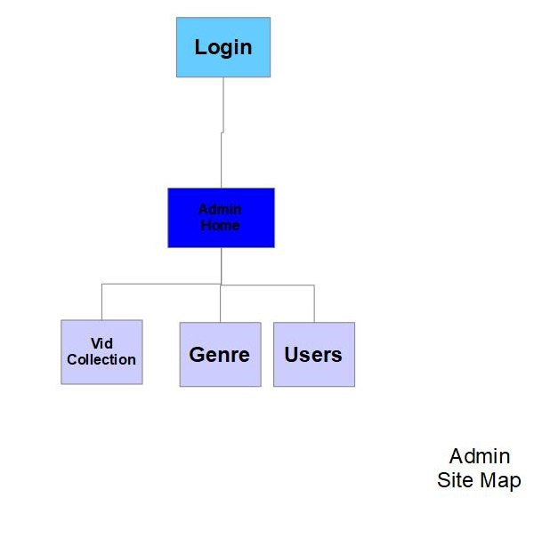

### Funflix Site Map:

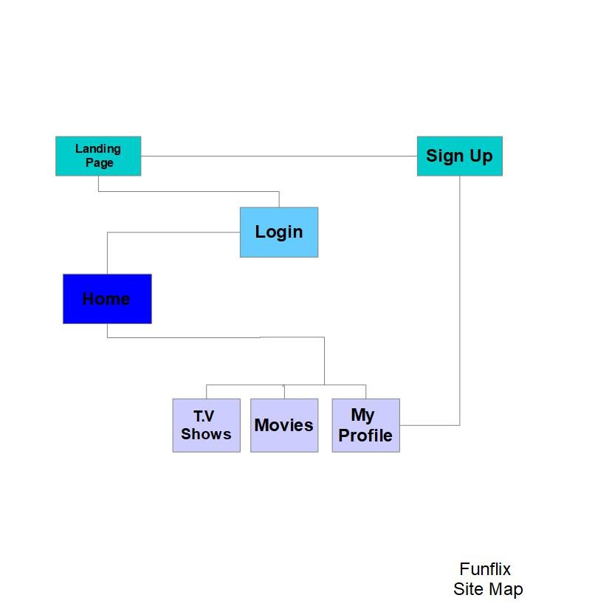

## 

## **Data Model:**

### Conceptual Data Model:

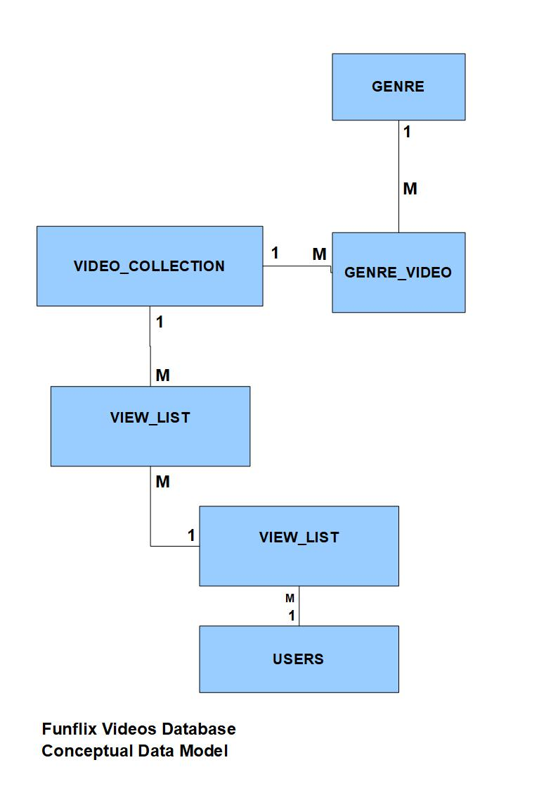

### ER Diagram

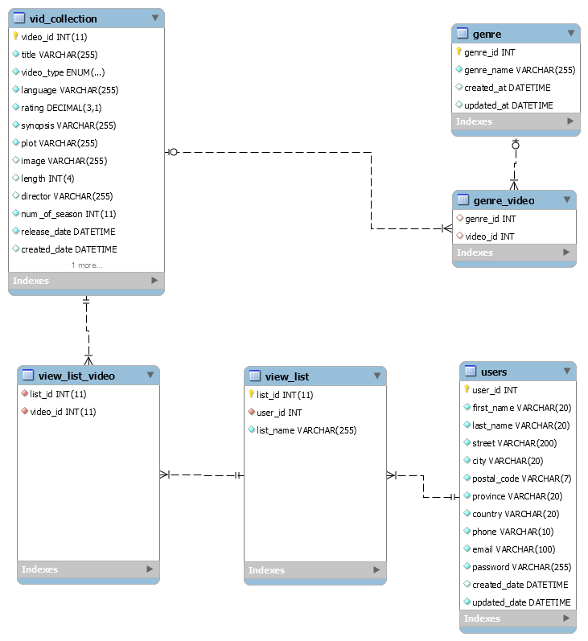

## **Invoice:**

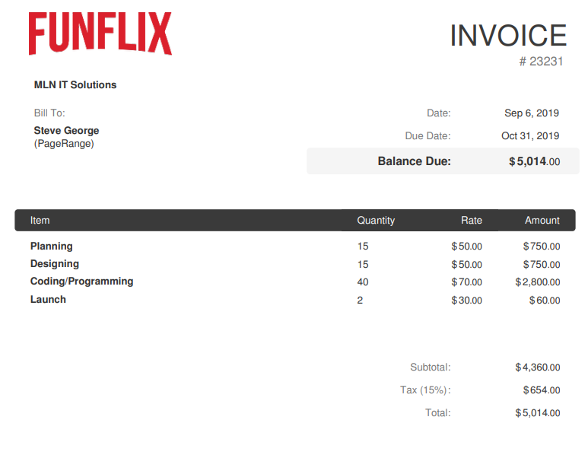

## **Conclusion:**

Thanks for giving the opportunity to send in a proposal. We really look forward to working with your organization on this project.